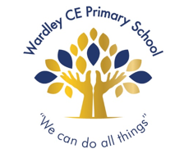
Reception newsletter, Autumn term 2

Dear parents and carers,

Here you will find useful information about what we will be doing over the next few weeks in Reception:

Physical development | We have our PE sessions on Thursdays.  Your child should come into school wearing their PE kits (black PE shorts or jogging bottoms, plain white t-shirt, black pumps or trainers).
Literacy  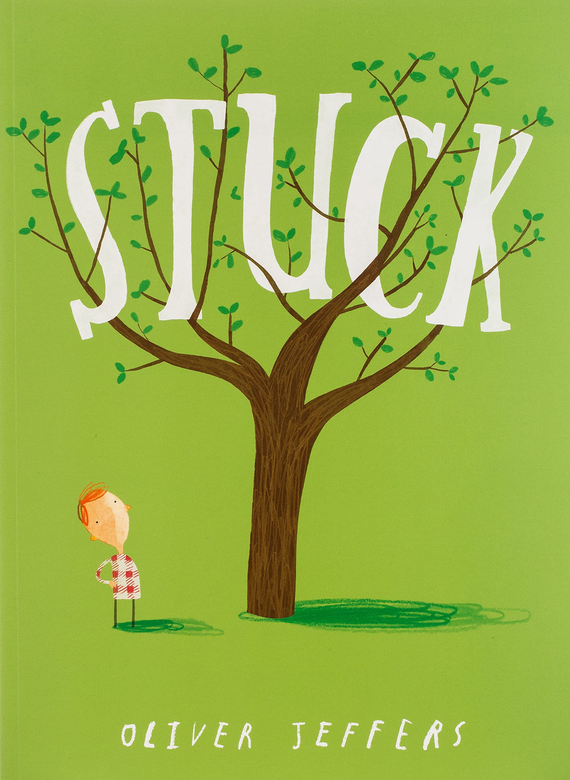 | In Read Write Inc, your child will continue practicing and developing their reading and writing skills.  Our focus story this half-term will be ‘Stuck’ by Oliver Jeffers.
Maths | 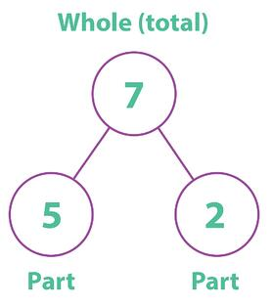  In maths this half term, we will be learning all about number bonds, doubling and addition. Number bond activities will introducing the following diagram to represent:  To help your child at home with this, bring number bonds into everyday activities.  eg, How many grapes do you have altogether? How many of your grapes are green? How many of your grapes are purple?
Understanding the World | We will be learning all about special celebrations such as Christmas and Diwali. We also would like children to talk about special celebrations they have been a part of such as birthdays or weddings.  Please send your child into school with a photograph of them at a special celebration so they can talk about it. These will also be used for a writing opportunity. Alternatively, if you would prefer to send in an electronic copy, it can be emailed to Miss Hargreaves using your child’s Google Classroom login.

Important things to remember:

Home reading | Home reading books will be changed Tuesday and Friday. Please make sure your child’s reading book bag, reading book and reading diary in school everyday both days.  It is important that you read your child’s books with them multiple times. This will help to build their confidence and increase their reading speed.
Labelling | We ask that all your child’s personal items are clearly labelled, including wellies, water bottles and coats.
Cold weather | With the cold weather upon us, please make sure that your child has a warm coat to wear whilst playing outside.  Feel free to send in gloves and hats, however we discourage wearing scarves for health and safety reasons

Something to try at home!

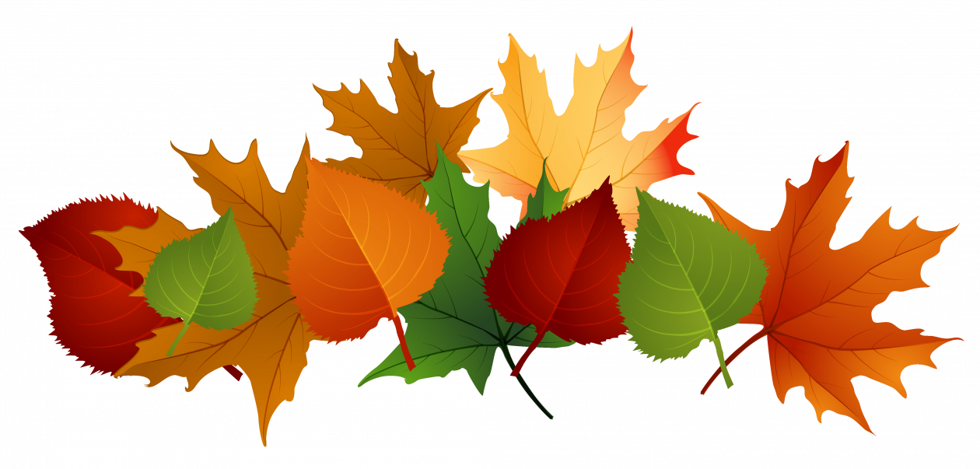  All about Autumn! | Develop an awareness of Autumn by taking a walk through the woods and collecting Autumn treasures. Feel free to collect some and bring them into school.  Become aware of the weather conditions in Autumn – windy weather, clothes worn, changes in the natural environment e.g. leaves falling, berries ripening etc.

Thank you for your ongoing support and if you have any questions or concerns that you would like to talk to me about, please do not hesitate to catch me at the classroom door or contact the school office to arrange an appointment.

Miss Hargreaves

