



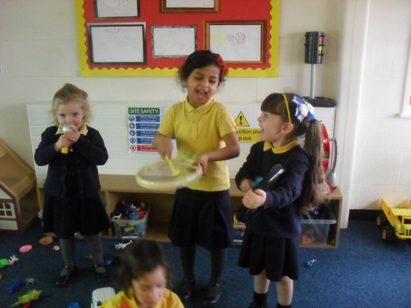

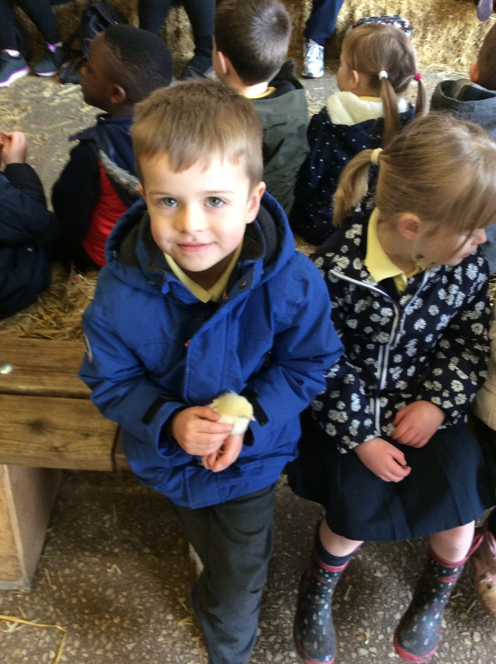

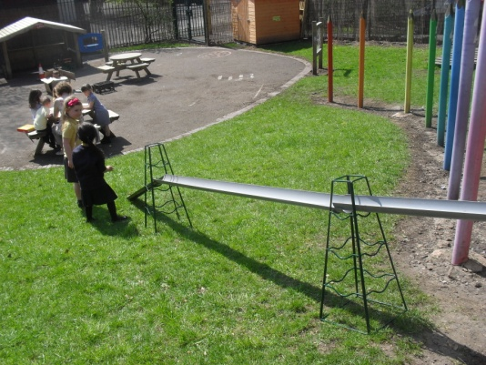

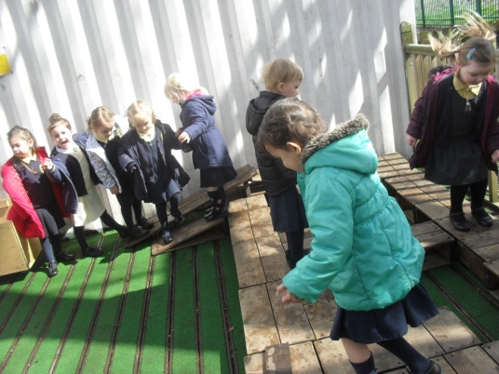

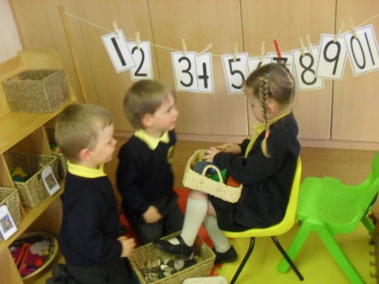

**Welcome to Nursery**

**Wardley CE Primary School**

Moss Bank Rd Swinton

Manchester M27 9XB

Tel: 0161 921 1098

Email: [wardley.ceprimaryschool@salford.gov.uk](mailto:wardley.ceprimaryschool@salford.gov.uk)

Head teacher: Mr M Foster

B.A. P.G.C.E. N.P.Q.H







**Introduction to the Nursery**

|  |
| --- |
| *‘Children get off to a flying start in early years. Children’s progress accelerates as they move from nursery into reception. They achieve equally well across almost every aspect of the early years curriculum. The early years leader makes sure that every child leaves the Reception class academically and socially, ready for key stage 1’* ***Ofsted June 2017*** |

Children come into Nursery Class at Wardley C of E Primary School in the September following their third birthday. Coming into the Nursery represents a big change in a child’s life. They will be meeting other children their own age and encountering challenging, new activities. They will have learnt a great deal already, from you and a variety of pre-school experiences.

They learn through play, growing in confidence, furthering their understanding of the world and developing new skills which provide a solid foundation for their school life.

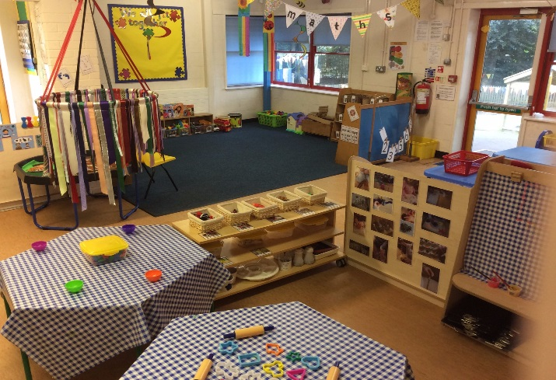 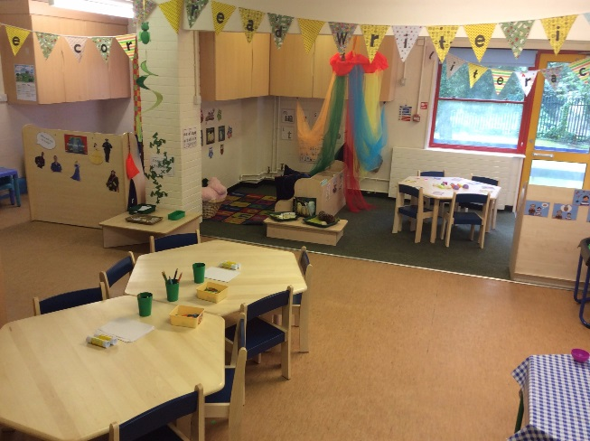

Our aim is to ensure that each child feels secure, valued and confident in the Nursery environment. We aim to foster a sense of achievement through learning activities which are rewarding and pleasurable for all children.

This booklet contains important information to help both you and your child feel welcome in our Nursery. Our partnership with you is as important as our relationship with your child. Your involvement in your child’s Nursery year will have a positive impact on their development and learning.

**If, at any time, you have a concern or query, please don’t hesitate to ask, so that we can resolve matters quickly.**

We look forward to sharing this year with you!

**Settling In**

Before your child starts Nursery, there are a number of things that you can do at home which will help your child to settle smoothly into Nursery life. You could talk to your child about their feelings and expectations: they may be anxious about being with adults they don’t know well, and sometimes new toilets are a big worry. You may be able to find a book about ‘Going to school’ to share with them. If your child thinks you are confident about where they are going to Nursery, they will probably feel settled too.

On a practical level, help your child learn to:

* manage some of their own clothes – putting on a coat,

pulling up trousers, putting on shoes

* go to the toilet confidently and wash their own hands
* use a knife and fork

Your child will feel confident and grown up if they can try to do these tasks when they start Nursery. Self-help skills are important, and practiced all year with the help of Nursery Staff.

Children settle into the Nursery at their own pace. Parents may wish to spend a little time with their child in the early stages. Try not to let your child see your anxieties about leaving them, and make sure they know that you will be coming back for them later. Then have some tissues ready for yourself, when you reach the school gate.

**Activities in the Nursery**

In Nursery we begin a two year programme called ‘The Early Years Foundation Stage’ which continues into and ends, for most children, in the Reception Class.

The EYFS principles are grouped into four themes:

A Unique Child

Positive Relationships

Enabling Environments

Learning and Development

Your child will be involved in a variety of activities every day in the Nursery which stimulate learning in an enjoyable way. Early Learning Goals for the Foundation Stage identify seven areas of learning as follows,

* **Personal, social and emotional development** involves helping children to develop a positive sense of themselves, and others; to form positive relationships and develop respect for others; to develop social skills and learn how to manage their feelings; to understand appropriate behaviour in groups; and to have confidence in their own abilities.
* **Communication and language** development involves giving children opportunities to experience a rich language environment; to develop their confidence and skills in expressing themselves; and to speak and listen in a range of situations.
* **Literacy** development involves encouraging children to link sounds and letters and to begin to read and write. Children must be given access to a wide range of reading materials (books, poems, and other written materials) to ignite their interest.
* **Mathematics** involves providing children with opportunities to develop and improve their skills in counting, understanding and using numbers, calculating simple addition and subtraction problems; and to describe shapes, spaces, and measures.
* **Understanding the world** involves guiding children to make sense of their physical world and their community through opportunities to explore, observe and find out about people, places, technology and the environment.
* **Physical development** involves providing opportunities for young children to be active and interactive; and to develop their co-ordination, control, and movement. Children must also be helped to understand the importance of physical activity, and to make healthy choices in relation to food.
* **Expressive arts and design** involves enabling children to explore and play with a wide range of media and materials, as well as providing opportunities and encouragement for sharing their thoughts, ideas and feelings through a variety of activities in art, music, movement, dance, role-play, and design and technology.

**Play**

Play underpins everything we do in Nursery; it is the way young

children learn, through enjoyment and challenge.

* Children have to experience play physically and emotionally.
* Children may play alone or with others.
* In their play children use the experiences they have and extend them to build up ideas, concepts and skills.
* While playing children can express fears and re-live anxious experiences. They can try things out, solve problems and be creative and can take risks and use trial and error to find things out.
* Play comes naturally and spontaneously to most children, though some need adult support.

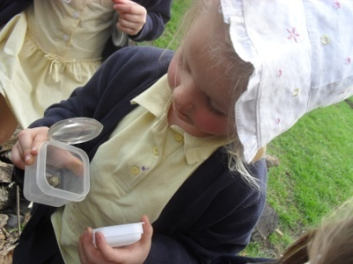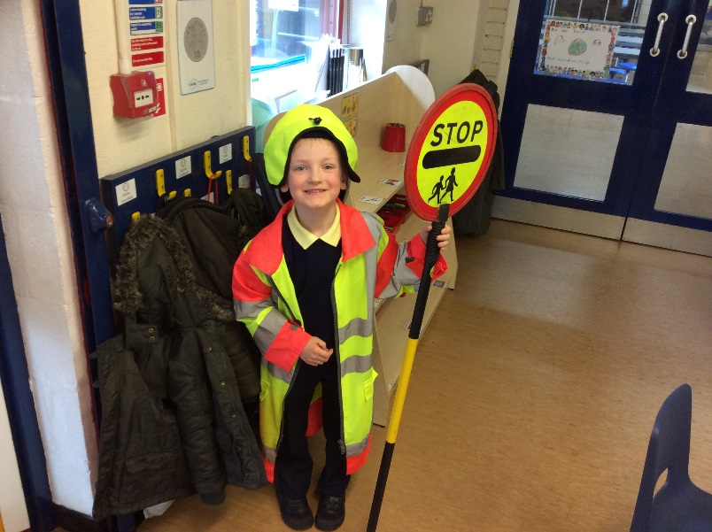

All children begin Nursery with a wide range of experiences. We aim to provide learning and development opportunities to meet all children’s needs. As adults, we need to

* Provide flexible resources that can be used in many different ways to facilitate children's play and exploration. These might include lengths of plastic guttering, tubing and watering cans near the sand and water play areas; lengths of fabric and clothes pegs in a box; large paintbrushes and buckets near the outside tap; boxes, clothes horses, old blankets and tablecloths to make dens and shelters.
* Observe children's play and help children to join in if they find it hard to be included, but watch and listen carefully before intervening.
* Find out how children play at home and value different cultural approaches to play.
* Value play which is based on people such as superheroes who may mean a lot to children, even if you do not appreciate them yourself!
* Tell and read stories and encourage children to act them out.

To do this, our planning builds on the children’s existing knowledge and interests, skills and experiences, developing their self-esteem and confidence to learn.

**Dressing for Nursery**

Wardley C of E School uniform is a navy blue cardigan or sweatshirt which can be purchased from our supplier McLellan Clothing Ltd, Moorside Road, Swinton (online at <https://www.mclellanclothing.com/wardley/>) or Whittakers Schoolwear 123-125 Chorley Rd, Swinton, Manchester M27 4AA. Children should also wear a white polo shirt, grey trousers or skirt & grey summer shorts. The summer dress for girls is blue.

Clothes that are easy for your child to manage are the most practical. During the learning process both indoors and out, clothes can get messy and dirty.

**No laces please!!**

**Pump bags**

Each child in the Nursery needs a simple drawstring type pump bag with their name on – any back packs will be returned to you, as there is not enough room on a peg. Please put in this bag a spare set of clothing (including underwear and socks) in case of accidents.

The children do not need pumps or P.E. kit when they first come to Nursery.

Each child also needs a pair of wellies for outside play**.**

**Please label all clothing with your child’s name.**

**Nursery Snacks**

All Nursery children are provided with a mid-morning and afternoon snack of fruit (such as apples, pears, bananas, oranges, tomatoes) and a carton of milk (without added fluoride).

Milk is free for Nursery children.

In addition, each child needs a plastic water bottle that you should bring in daily, containing fresh water only. Juice/flavoured water is not permitted.

All children should be encouraged to drink water from an early age to keep them hydrated during the day.

**Lunch**

We encourage all full time place children to have a school lunch, except on the rare occasion that a medical condition makes this inappropriate. Lunch-time is a very social occasion – we help the children to develop their use of cutlery, and encourage them to try a broad variety of food.

Dinner money is payable on a Monday morning through via the school gateway (online) at [www.schoolgateway.com](http://www.schoolgateway.com). We do not accept cash. The cost of a school meal is currently £2.10 (£10.50 per week)

If you think that you may be eligible for free meals, please contact the school office.

**Behaviour in the Nursery**

There are simple rules in the Nursery which are there to make sure that all children safe and secure. These are called the Golden Rules and are outlined below.

* We work hard
* We are gentle
* We are kind and helpful
* We are honest
* We listen
* We look after property

We also encourage the children to use good manners at all times.

Children learn from us, at home and school, what is acceptable behavior, and we reinforce this through praise. If an incident or conflict occurs, we deal with it as quickly as possible in Nursery, discussing with the children why their behavior has caused upset, encouraging them to come up with solutions with their friends.

In line with the rest of the school we encourage children to share their problems with a member of staff, rather than to physically retaliate. In most cases, as part of day-to-day life, conflicts are dealt with in school. In some circumstances, it may be necessary to inform you, and ask for your help in resolving a matter. If you, or indeed we, have a concern, this will be discussed away from your child at the end of a school day, so that we can deal with any problems calmly and quietly. We keep parents informed of any problems, and ask you to support our behaviour policy.

**If your child is going to be absent from school for any reason, please tell the Nursery Staff, or telephone the school to let us know.**

**Jewellery**

In line with the rest of the school, jewellery is not permitted in the Nursery for reasons of safety. If your child has pierced ears, please ensure your child only wears studs. For P.E. sessions studs will need to be removed or covered. We will let you know what day P.E. sessions will take place.

**Contact Information**

It is vital that the Nursery staff have day-time contact telephone numbers for yourself and a relative or friend in case your child is ill or has an accident during the day. If you change any of these telephone numbers, address or work place during the year, please let us know as soon as possible in writing.

**Collection of children**

Please let us know who will be collecting your child. If, for any reason, someone else has to come, please let us know in advance, either in the morning or by phoning the school. We can then reassure your child about who will be picking them up. If we have not been told of a change, we may have to contactyou before allowing your child to leave Nursery – in the interest of safety.

**Nursery times**

Nursery doors open at 8.55am to provide an opportunity for you to speak to your child’s teacher.

* The Nursery day begins at 9.00am.
* The morning session ends at 11.30.
* Lunch time begins at 11.30am.
* Our afternoon session begins at 13.00pm.
* The Nursery day finishes at 15.05pm.

We hope that this booklet has answered some important questions which you may have had about the Nursery. If you require any further information, please contact the school on **0161 921 1098 or e mail** [**wardley.ceprimaryschool@salford.gov.uk**](mailto:wardley.ceprimaryschool@salford.gov.uk)

### **And finally**…

We are fully confident that your child will settle into Nursery. If your child is upset when you leave, we will telephone you later to reassure you that they are okay. Starting school can be traumatic for parents as well as children! We hope to minimise this by being available to answer any queries of worries you may have on a day-to-day basis.